**CSV Management Subsystem Functional Requirements, v0.3**

**Author: Josh Trimm**

**Edited by Phil Pfeiffer**

**Last Updated 12 September 2021**

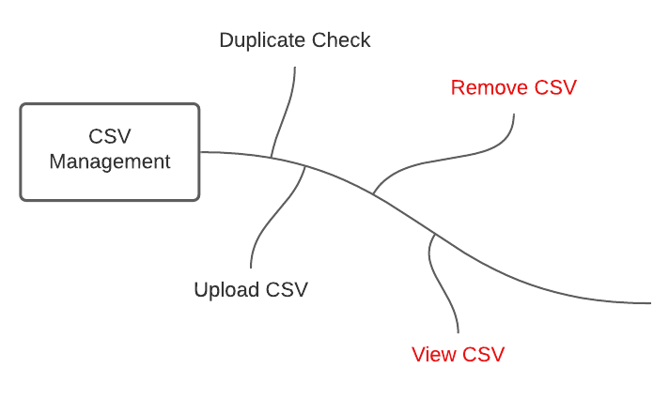

# Description

The CSV Management system shall manage the uploading, storage, altering, viewing, and removal of CSVs from the CPH system. This module is not responsible for sending datapoints, it only manages the CSV’s so other parts of the system can pull data from the CSV’s.

# Functional Requirements

1. The CSV Management System shall enable Admins and Cartographers to upload yearly CSV health indicators from any year to the system.
   1. The CSV Management System shall check if the user is uploading a duplicate CSV.
      1. The system will check the hash functions of each file to ensure duplicates are not uploaded to save disk space.
      2. The system will check for the same year within the CSV being uploaded. If the year already exists, the user will be prompted to delete the previously uploaded year before uploading the requested year.
2. The CSV Management System shall retrieve the year of the CSV being uploaded.
3. The CSV Management System shall save the original CSV in a separate location than the altered CSV.
4. After uploading the CSV, the system shall remove the second row of the CSV.
5. Admins and Cartographers shall be able to view the uploaded CSVs in the form of an excel spreadsheet displayed in the browser.